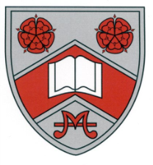

College applications submitted in December.

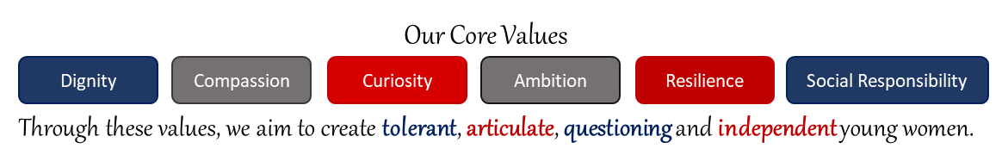

New Year celebrations go with a bang.

Resolution to try your best and go for it!



Early February – Exams boards to release information on exam content for most subjects.

1st March – Revision Workshop and Parents Presentation.

February to March: Targeted small group interventions aimed at specific weaknesses.



Revision - March Mock preparations smoothly transition in summer exam programme

March Mocks

21st March to 1st April

NEA submission deadlines

April to May.

Easter Holiday - Fri 2nd April to Mon 18th April

First day of Ramadan 3rd April

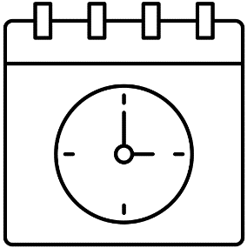

MFL Oral Assessments   
(French and German)

April-May

GCSE Exam Season.

Some key dates:

First Exams:

* Religious Studies – 16th May.
* Biology Paper 1 - 17th May.
* English Language Paper 1 - 18th May
* Maths Non-Calculator - Exam 20th May

Last Exams:

* English Language Paper 2 – 10th June.
* Maths Paper 3 Calculator - 13th June
* Physics Paper 2 - 20th June

Relax, recharge, revise…

Summer Half term

Sat 28th to Sun 5th June

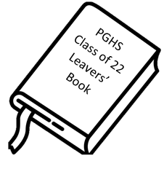

Leavers Assembly

PM Friday 24th June

Prom (Barton Manor Hotel)

7.00 - 28th June

GCSE Results Day

Thursday 25th August



