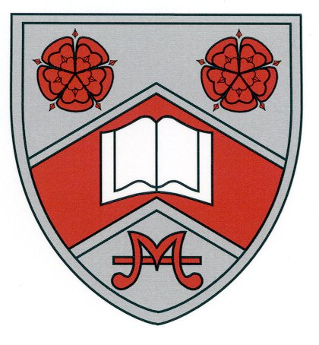

Penwortham Girls’ High School

Medical Questionnaire for Year 10 Work Experience

The following information is required by the employer in order to provide a safe and healthy placement for your daughter.

Failure to disclose accurate information could put your daughter at risk and will result in the placement being withdrawn:--

To be completed by the parent or guardian of:

Student’s Name: …………………………………………………………………..

Form: …..…………………….

Does she: | YES OR  NO | IF YES PLEASE DETAIL
1. have any restrictions of normal physical activity?
2. need support during the period of the work placement?
3. have skin allergies or eczema? (or any other allergies, e.g. to nuts?)
4. have bronchitis, asthma or chest complaints?
5. have a hearing disability or discharging ears?
- 6. have heart disease/any other related which would affect their capacity to carry out physical tasks?
7. have diabetes?
8. experience fits or fainting attacks?
9. have a significant colour vision defect or other visual disability?
10. have a learning disability which might affect their ability to understand or act on instructions?
- 11. have any other health problems (including the need for regular medication?)

* Attach a separate sheet of paper if necessary.

Signed:……………………………………………………………….Parent/Carer

Date:…………………………………………………….

