Penwortham Girls’ High School

Strengthening Your
Emotional Health and Wellbeing
& Building Resilience
SELF-HELP GUIDE
Name:

Everyone’s emotional health and wellbeing can suffer at times. There can be many reasons for this, ranging from a serious fall-out with a good friend, to a family bereavement.
Getting support from a Mental Health First Aider, one of our counsellors, or even a mental health practitioner through CAMHS or another agency is sometimes required.
However, there are no ‘quick fixes’ with mental health, and there are several important ways that you can help yourself in the longer term.
Self-help is therefore an essential first step that you must take and this booklet will provide you with a range of strategies that you can put in place to improve your emotional health and wellbeing.
These strategies must be fully implemented to ensure that any further support you receive (for example, from a counsellor) is as helpful as it can be. Most importantly, the strategies outlined in this booklet will strengthen your emotional resilience, ensuring that you are better able to cope with setbacks in the future.

Sleep Routines

Advice and support https://www.nhs.uk/live-well/sleep-and-tiredness/

A minimum of 8 to 10 hours' good sleep on school nights is recommended for teens.

Limit screens in the bedroom
If possible, do not have a mobile, tablet, TV or computer in the bedroom at night, as the light
from the screen interferes with sleep.

Having screens in the bedroom also means you’re more likely to stay up late interacting with
friends on social media. Have at least an hour of screen-free time before going to sleep.

Exercise for better sleep
Regular exercise helps you sleep more soundly, as well as improving your general health.

You should be aiming for at least 60 minutes' exercise every day, including aerobic activities
such as fast walking and running.

Exercising out in daylight will help to encourage healthy sleep patterns, too.

Cut out the caffeine
Try to cut out or drink less caffeine – found in drinks such as coke and coffee.
Too much caffeine can stop you falling asleep and reduce the amount of deep sleep you have.

Do not binge before bedtime
Eating too much, or too little, close to bedtime can lead to an overfull or empty stomach.
This can be a cause of discomfort during the night and may prevent sleep.

Have a good routine
Get into a regular bedtime routine. Doing the same things in the same order an hour or so
before bed can help them drift off to sleep.

Create a sleep-friendly bedroom
Ensure you have a good sleeping environment – ideally a room that is dark, cool, quiet and comfortable.
It might be worth investing in thicker curtains or a blackout blind to help block out early
summer mornings and light evenings.
Avoid long weekend lie-ins that play havoc with your body clock!

Reflect on your sleep routines and describe them below. Identify where you could make improvements so that you get better sleep.

________________________________________________________

________________________________________________________

________________________________________________________

________________________________________________________

________________________________________________________

________________________________________________________

________________________________________________________

________________________________________________________

Now make a list of actions that will improve your sleep routines. Ask a parent to support you with them.

________________________________________________________

________________________________________________________

_______________________________________________________

________________________________________________________

________________________________________________________

________________________________________________________

________________________________________________________

________________________________________________________

Please record your sleep patterns for three weeks:

Sleep Diary

Week 1:
________________________________________________________

________________________________________________________

_______________________________________________________

________________________________________________________

________________________________________________________

________________________________________________________

________________________________________________________

Week 2:
______________________________________________________

________________________________________________________

_______________________________________________________

________________________________________________________

________________________________________________________

________________________________________________________

________________________________________________________

Week 3:
________________________________________________________

________________________________________________________

_______________________________________________________

________________________________________________________

________________________________________________________

________________________________________________________

________________________________________________________

Exercise, Hobbies and Interests

Advice and support

https://www.mind.org.uk/information-support/tips-for-everyday-living/physical-activity-and-your-mental-health/choosing-an-activity/

The benefits of moving more
Being active isn't just about feeling stronger, fitter, more energetic and sleeping better. It's also about having fun! You need to be active for at least 60 minutes a day, with 30 minutes of this outside of school. This should include 3 sessions a week of activity that strengthens muscles and bones, so mix it up!

And it's not just physically that you’ll benefit
– being active also helps with mental health.
Evidence shows that children and young
people who are more active have more confidence, higher self-esteem, less anxiety
and stress, and better social skills – attributes that can help them deal with the challenges they face in daily life.

Hobbies and interests give you a chance to meet new people, discover new passions,
develop skills outside of school, and do something everyone should do: have fun.

Two of the most important things that happen during the teen years are identity formation and differentiation.
Identity formation is exactly what it sounds like: it’s the process of becoming an individual with an entire set of personal wants, needs, skills, and preferences. Differentiation is part of identity formation, but – and this
is crucial – differentiation is special. It’s the formation of
an identity outside and apart from parents and family.
That’s where hobbies and interests come in.

Have you had a look at the wide range of activities and clubs that run at our school? Have you let
an activity or hobby drift that you could pick up again? Do you have a friend who could introduce you to a new sport, hobby or interest?

Reflect on your levels of exercise and the time you spend on your hobbies and interests and describe them below. Identify where you could make improvements.

________________________________________________________

________________________________________________________

________________________________________________________

________________________________________________________

________________________________________________________

________________________________________________________

________________________________________________________

________________________________________________________

Now make a list of actions that will improve your levels of exercise and the time you spend on hobbies and interests. Ask a parent to support you with them.

________________________________________________________

________________________________________________________

_______________________________________________________

________________________________________________________

________________________________________________________

________________________________________________________

________________________________________________________

________________________________________________________

Please record your exercise, hobbies and interests activity for three weeks:

Exercise, Hobbies and Interests Diary

Week 1:
________________________________________________________

________________________________________________________

_______________________________________________________

________________________________________________________

________________________________________________________

________________________________________________________

________________________________________________________

Week 2:
______________________________________________________

________________________________________________________

_______________________________________________________

________________________________________________________

________________________________________________________

________________________________________________________

________________________________________________________

Week 3:
________________________________________________________

________________________________________________________

_______________________________________________________

________________________________________________________

________________________________________________________

________________________________________________________
________________________________________________________

Diet

Advice and support
https://www.bbcgoodfood.com/howto/guide/healthy-eating-what-adolescence-need

As a teenager, your body is going through many physical changes – changes that need to be supported by a healthy, balanced diet.

By eating a varied and balanced diet as shown in the Eatwell Guide, you should be able to get all
the energy and nutrients you need from the food and drink you consume, allowing your body to grow and develop properly. Good physical health is essential for good mental health.
Eating healthily doesn't have to mean
giving up your favourite foods. It simply means eating a variety of foods and cutting down on food and drinks high in fat and sugar, such as sugary fizzy drinks, crisps,
cakes and chocolate. These foods should
be eaten less often and in smaller
amounts. Eating a balanced diet is the
way to go. Dieting, skipping breakfast or starving yourself don't work.

Stay hydrated
Aim to drink 6 to 8 glasses of fluids a day – water and lower-fat milk are both healthy choices.

Feeling tired?
If you often feel run down, you may be low on iron. Teenage girls are especially at risk because
they lose iron during their period. Try to get your iron from a variety of foods. Some good sources are red meat, breakfast cereals fortified with iron, and bread.

Eating disorders
Does eating make you feel anxious, guilty or upset? An eating disorder is serious and isn't
something you should deal with on your own. Talk about it with someone you trust, there are treatments that can help, and you can recover from an eating disorder. Learn more about eating disorders.

Reflect on your diet and describe it below. Identify where you could make improvements.

________________________________________________________

________________________________________________________

________________________________________________________

________________________________________________________

________________________________________________________

________________________________________________________

________________________________________________________

________________________________________________________

Now make a list of actions that will improve your diet. Ask a parent to support you with them.

________________________________________________________

________________________________________________________

_______________________________________________________

________________________________________________________

________________________________________________________

________________________________________________________

________________________________________________________

________________________________________________________

Please record what you eat and drink for three weeks:

Diet Diary

Week 1:
________________________________________________________

________________________________________________________

_______________________________________________________

________________________________________________________

________________________________________________________

________________________________________________________

________________________________________________________

Week 2:
______________________________________________________

________________________________________________________

_______________________________________________________

________________________________________________________

________________________________________________________

________________________________________________________

________________________________________________________

Week 3:
________________________________________________________

________________________________________________________

_______________________________________________________

________________________________________________________

________________________________________________________

________________________________________________________

________________________________________________________

Personal Organisation

Advice and support
https://www.teenvogue.com/story/school-organization-time-management-tips

The brain’s frontal lobes help us to be organised, such as being able to switch between tasks, weighing things up and planning ahead. However, the frontal lobes are not fully developed until early adulthood (around 25 years old) – which goes some way to explaining why teenagers can
find personal organisation challenging and therefore stressful!
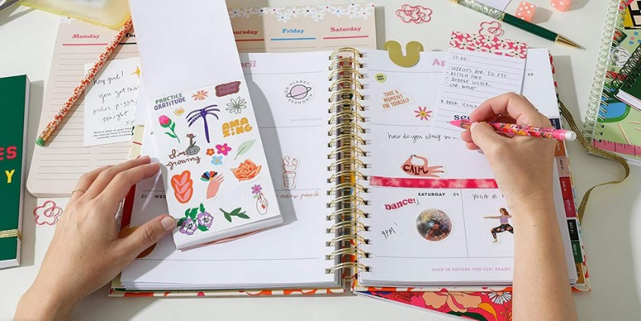
Being better at task planning, time management and self-organisation is a real advantage when it comes to
studying. So, while we are waiting for
our teens’ brains to catch up and get
with the programme, there is a lot you can do to get better organised and
reduce the stress of falling
behind, missing deadlines etc.

Here's a quick checklist of things that can help you organise, focus, and get it done:

- DO know your deadlines.
- DO make a calendar of upcoming events and due dates.
- DO include social events on this calendar for time management.
- DO understand the assignment and expectations.
- DO give yourself a quiet place to study with all the materials you need.
- DO give yourself brief breaks.
- DON'T put work off until the last minute; you'll be too frantic to focus.
- DON'T do your homework late at night or in bed.

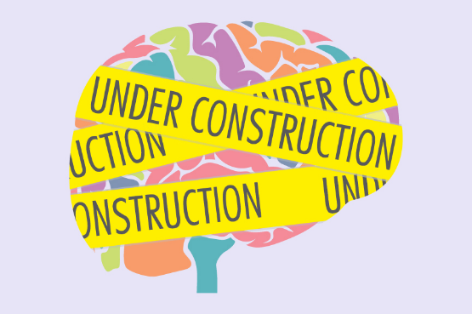
The more you use planning skills, the quicker those
neurons will develop in the brain.

Another advantage of building self-organisation skills is
that it cuts down on nagging from parents!

Reflect on your personal organisation and describe it below. Identify where you could make improvements.

________________________________________________________

________________________________________________________

________________________________________________________

________________________________________________________

________________________________________________________

________________________________________________________

________________________________________________________

________________________________________________________

Now make a list of actions that will improve your personal organisation. Ask a parent to support you with them.

________________________________________________________

________________________________________________________

_______________________________________________________

________________________________________________________

________________________________________________________

________________________________________________________

________________________________________________________

________________________________________________________

Please record important deadlines met / not met e.g. homework, as well as punctuality to school for three weeks:

Personal Organisation Diary

Week 1:
________________________________________________________

________________________________________________________

_______________________________________________________

________________________________________________________

________________________________________________________

________________________________________________________

________________________________________________________

Week 2:
______________________________________________________

________________________________________________________

_______________________________________________________

________________________________________________________

________________________________________________________

________________________________________________________

________________________________________________________

Week 3:
________________________________________________________

________________________________________________________

_______________________________________________________

________________________________________________________

________________________________________________________

________________________________________________________
__________________________________________________

Social Media Use / Screen Time

Advice and support
https://www.youngminds.org.uk/young-person/coping-with-life/social-media-and-mental-health/

The negative effects of social media use are due mostly to what screen time takes you away
from: sleep and exercise. In a 2017 study, Instagram browsing was related to increases in adolescents’ depressed mood. Similarly, a teen’s initial depressed mood was also related to increases in Instagram posting. This makes for a painful cycle: The more you browse, the more depressed you are; the more depressed you are, the more you post.

Researchers also found that cyberbullying and lack of sleep accounted for 60 percent of the connection between social media and psychological distress. For girls, increased social media use was directly linked to poorer well-being.

Find a safe space to check in. Use one-on-one time with a family member or friend to
confidentially and candidly discuss social and emotional well-being.
Create your own boundaries. What’s a good balance between screen time and other responsibilities? Set limits on your own screen time or social apps.
Respect others’ boundaries. If you know your peers are offline or headed to bed at night, respectfully avoid keeping them awake with messages or social media posts.
Talk openly about self-awareness and emotions. Think about the effects that cyberbullying has
on others or reflect on a time when you were affected by similar behaviour.
Role-play hypothetically. How would you handle it if someone posted things about you that
aren’t true? Who would you ask if you needed help? Talk about strategies for responding—or not responding—before reacting in the moment.
Give your brain a break from screen time. Schedule or plan time to spend away from screens,
such as meal times, exercising and school work, if possible. Think about creative hobbies that
don’t involve screens.
Find other ways to connect online. Instead of scrolling, commenting or practicing one-way communications, try other platforms that allow for real-time dialogues like FaceTime, Zoom calls
or virtual game platforms.
Spend time with people in your household. In-person interactions like playing games, watching movies or going for walks can help connections feel more real.
Limit consumption of traumatic videos. Consuming news stories about violence and trauma can
be harmful to viewers of all ages but especially those who may need parental guidance to process what they’re seeing.
Look out for symptoms of overuse. Practice doing a body scan to identify ways that screen time
has created physical reactions, such as headaches, dry eyes, hunger and dehydration.

Reflect on your use of social media and screen time and describe it below. Identify where you could make improvements.

________________________________________________________

________________________________________________________

________________________________________________________

________________________________________________________

________________________________________________________

________________________________________________________

________________________________________________________

________________________________________________________

Now make a list of actions that will improve your use of social media and screen time. Ask a parent to support you with them.

________________________________________________________

________________________________________________________

_______________________________________________________

________________________________________________________

________________________________________________________

________________________________________________________

________________________________________________________

________________________________________________________

Please record your use of social media and screen time for three weeks:

Social Media and Screen Time Diary

Week 1:
________________________________________________________

________________________________________________________

_______________________________________________________

________________________________________________________

________________________________________________________

________________________________________________________

________________________________________________________

Week 2:
______________________________________________________

________________________________________________________

_______________________________________________________

________________________________________________________

________________________________________________________

________________________________________________________

________________________________________________________

Week 3:
________________________________________________________

________________________________________________________

_______________________________________________________

________________________________________________________

________________________________________________________
________________________________________________________

Relationships with friends and family

Advice and support
https://www.helpguide.org/articles/relationships-communication/making-good-friends.htm

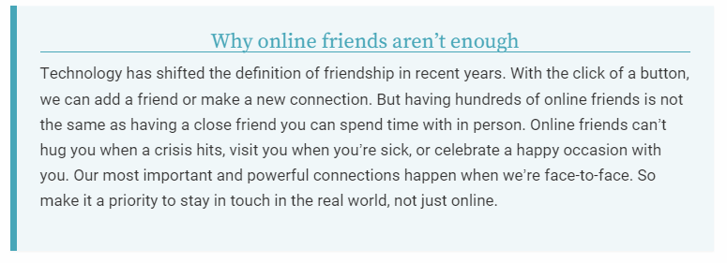
Friendship—that close connection with another person which allows us to feel valued and cared for—is vital at any stage of life. The need for love and belonging has long been established as one
of our basic needs as human beings.

And it has been well documented that having strong, healthy relationships improves our self-esteem and overall well-being. It is important to remember that just like so many aspects of adolescent development, making friends is a skill that can be learned.

Here are some tips for improving friendship skills:

Be the friend that you would like to have. Treat your friend just as you want them to treat you.
Be reliable, thoughtful, trustworthy, and willing to share yourself and your time.
Be a good listener. Be prepared to listen to and support friends just as you want them to listen to and support you.
Give your friend space. Don’t be too clingy or needy. Everyone needs space to be alone or spend time with other people as well.
Don’t set too many rules and expectations. Instead, allow your friendship to evolve naturally. You’re both unique individuals so your friendship probably won’t develop exactly as you expect.
Be forgiving. No one is perfect and every friend will make mistakes. No friendship develops smoothly so when there’s a bump in the road, try to find a way to overcome the problem and
move on. It will often deepen the bond between you.

The need for connection and belonging extends beyond friendships with peers. Make connections with your family and the adults in your life. Find little opportunities to connect like taking the dog for a walk with your Mum or helping your Dad with making an evening meal. Suggest watching a film with a brother or sister, for example. This can be both rewarding and can hep you to build
solid, healthy relationships in their lives that they can count on unconditionally. These
relationships make it so much easier to endure the roller coaster of adolescent friendships.

Reflect on your relationships with friends and family and describe them below. Identify where you could make improvements.

________________________________________________________

________________________________________________________

________________________________________________________

________________________________________________________

________________________________________________________

________________________________________________________

________________________________________________________

________________________________________________________

Now make a list of actions that will improve your relationships with friends and family. Ask a parent to support you with them.

________________________________________________________

________________________________________________________

_______________________________________________________

________________________________________________________

________________________________________________________

________________________________________________________

________________________________________________________

________________________________________________________

Please record what you did with friends and family for three weeks:

Friends and Family Diary

Week 1:
________________________________________________________

________________________________________________________

_______________________________________________________

________________________________________________________

________________________________________________________

________________________________________________________

________________________________________________________

Week 2:
______________________________________________________

________________________________________________________

_______________________________________________________

________________________________________________________

________________________________________________________

________________________________________________________

________________________________________________________

Week 3:
________________________________________________________

________________________________________________________

_______________________________________________________

________________________________________________________

________________________________________________________

________________________________________________________
_______________________________________________

Panic attacks

Advice and support
https://www.youngminds.org.uk/young-person/my-feelings/panic-attacks/

A panic attack is a sudden and intense feeling of fear and anxiety. It can happen quite suddenly
and feel overwhelming or scary.
You might feel a few of these symptoms at the same time or have a different reaction. Everyone experiences panic attacks differently and your feelings are valid. During a panic attack, you might also feel like you can’t control what’s happening to your body, or feel out of touch with what’s
going on around you. You might feel scared that your body is in danger or feel like you’re having a heart attack.
Although this can feel very frightening, it’s important to know that a panic attack won’t cause you any harm. Even if you don’t feel it during an attack, try to remember you are in control and the feeling will pass.

Steps you should take:

Focus on breathing in slowly, then breathing out slowly. It can be helpful to count when you’re breathing to focus your mind. You can start small at first, like counting to three as you breathe in and counting to three as you breathe out. When you begin to calm down, you can increase how
long you hold each breath to five seconds or seven seconds.
There are lots of different breathing techniques that you can try. You can use apps like Headspace and Calm to practise breathing exercises, or have a look online and see what
works best for you.

If a situation is making you feel panicked, try and find a safe space where you can take a moment
to breathe and calm your thoughts. If you can’t physically go to a safe space, try visualising
yourself somewhere where you feel calm, like on a favourite holiday.

When you are having a panic attack, you can feel out of touch with things around you. One way
you can feel back in touch with your surroundings is by picking out five things you can see, hear, taste, touch, or smell. This is called a grounding exercise. You can pick a couple for each sense,
or focus on one sense, like finding five things that you can see. This can help you feel connected
with your surroundings and in control.

If you are worried about when you are next going to have a panic attack, here are some things
that can help you cope.
Speak to someone you trust. If you are feeling anxious or worried that you might have a panic attack, talk to friends or family. If you are worried about having a panic attack at school,
speak to a teacher or a member of staff.

Relaxation Strategies

Advice and support
https://www.mind.org.uk/information-support/tips-for-everyday-living/relaxation/relaxation-exercises/

Here are four relaxation exercises that can help you manage stress.

1. Yoga
Yoga offers a variety of physical and mental health benefits, such as improved flexibility, posture, and strength as well as a sense of inner calm.
You can learn yoga in a variety of ways. Attend a yoga class or look for beginners yoga videos on YouTube that will let you practice in the privacy of your own home.

2. Meditation
Learning how to do so through meditation can provide improved physical and emotional benefits. Meditation has been linked to everything from increased happiness to improved immunity.
There are several different types of meditation, but at the core of all of them is the desire to calm the mind. Explore meditation tutorials, guided meditation, or a meditation app.

3. Deep Breathing and Grounding Exercises
Take time and pay attention to your breathing. Slow, deep, long breaths can help you maintain a sense of calm or help you return to a calmer state, when you’re feeling anxious. Once you find
your breath, complete the grounding exercise described below:

Acknowledge:
five things you can see around you
four things you can touch
three things you can hear
two things you can smell
one thing you can taste

4. Progressive Muscle Relaxation
Stress can cause people to tense their muscles, and the tenser they feel, the more stressed out
they become. Letting go of that tension through progressive muscle relaxation can be a simple
way to let go of stress.

Start by tensing and relaxing each muscle group—moving from your toes all the way up to your head. By the time you're done, all of your muscles should be relaxed.

