A CHRISTMAS CAROL: REVISION BOOKLET

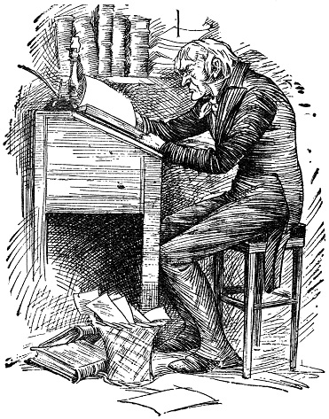

AO1: Read, understand and respond to texts. Students should be able to: maintain a critical style and develop an informed personal response, use textual references, including quotations, to support and illustrate interpretations.
AO2: Analyse the language, form and structure used by a writer to create meanings and effects, using relevant subject terminology where appropriate.
AO3: Show understanding of the relationships between texts and the contexts in which they were written.
Throughout this booklet, you will find a series of activities designed to help you revise Charles Dickens’ ‘A Christmas Carol’. Remember to focus on the assessment objectives and what you are actually being marked on. You need to demonstrate you can meet all three in order to succeed in the exam.
ACTIVITY ONE: The plot
Read and summarise
Read the plot of ‘A Christmas Carol’ and summarise what you have learned into four bullet points at the end of each section.

READ
A mean-spirited, miserly old man named Ebenezer Scrooge sits in his counting-house on a cold Christmas Eve. His clerk, Bob Cratchit, shivers in the anteroom because Scrooge refuses to spend money on heating coals for a fire. Scrooge's nephew, Fred, pays his uncle a visit and invites him to his annual Christmas party. Two portly gentlemen also drop by and ask Scrooge for a contribution to their charity. Scrooge reacts to the holiday visitors with bitterness and venom, spitting out an angry "Bah! Humbug!" in response to his nephew's "Merry Christmas!"
Later that evening, after returning to his dark, cold apartment, Scrooge receives a chilling visit from the ghost of his dead partner, Jacob Marley. Marley, looking haggard and pale, tells his unfortunate story. As punishment for his greedy and self-serving life, his spirit has been condemned to wander the Earth weighted down with heavy chains. Marley hopes to save Scrooge from sharing the same fate. Marley informs Scrooge that three spirits will visit him during each of the next three nights. After the ghost disappears, Scrooge collapses into a deep sleep.

SUMMARISE

˙
˙
˙
˙

READ
He wakes moments before the arrival of the Ghost of Christmas Past, a strange childlike phantom with a brightly glowing head. The spirit escorts Scrooge on a journey into the past to previous Christmases from his earlier years. Invisible to those he watches, Scrooge revisits his childhood school days, his apprenticeship with a jolly merchant named Fezziwig, and his engagement to Belle, a woman who leaves Scrooge because his lust for money overshadows his ability to love another. Scrooge, deeply moved, sheds tears of regret before the phantom returns him to his bed.
The Ghost of Christmas Present, a majestic giant dressed in a green fur robe, takes Scrooge through London to unveil Christmas as it will happen that year. Scrooge watches the large, bustling Cratchit family prepare a miniature feast in its meagre home. He discovers Bob Cratchit's crippled son, Tiny Tim, a courageous boy whose kindness and humility warms Scrooge's heart. The ghost then zips Scrooge to his nephew's to witness the Christmas party. Scrooge finds the jovial gathering delightful and pleads with the spirit to stay until the very end of the festivities. As the day passes, the spirit ages, becoming noticeably older. Toward the end of the day, he shows Scrooge two starved children, Ignorance and Want, living under his coat. He vanishes instantly as Scrooge notices a dark, hooded figure coming toward him.

SUMMARISE

˙
˙
˙
˙

READ
The Ghost of Christmas Yet to Come leads Scrooge through a sequence of mysterious scenes relating to an unnamed man's recent death. Scrooge sees businessmen discussing the dead man's riches, some vagabonds trading his personal effects for cash, and a poor couple expressing relief at the death of their unforgiving creditor. Scrooge, anxious to learn the lesson of his latest visitor, begs to know the name of the dead man. After pleading with the ghost, Scrooge finds himself in a churchyard, the spirit pointing to a grave. Scrooge looks at the headstone and is shocked to read his own name. He desperately implores the spirit to alter his fate, promising to change his insensitive, greedy ways and to honour Christmas with all his heart. Whoosh! He suddenly finds himself safely tucked in his bed.
Overwhelmed with joy by the chance to redeem himself and grateful that he has been returned to Christmas Day, Scrooge rushes out onto the street hoping to share his newfound Christmas spirit. He sends a giant Christmas turkey to the Cratchit house and attends Fred's party, to the surprise of the other guests. As the years go by, he holds true to his promise and honours Christmas with all his heart: he treats Tiny Tim as if he were his own child, provides lavish gifts for the poor, and treats his fellow human beings with kindness, generosity, and warmth.

SUMMARISE

˙
˙
˙
˙

ACTIVITY TWO: Low Stakes Quiz
Answer the multiple choice questions.
Who is Scrooge’s clerk?  - Bob Cratchit  - Fred  - Jacob Marley  - Fezziwig  Who is Jacob Marley?  - Scrooge’s nephew  - A charity worker  - Scrooge’s clerk  - Scrooge’s old business partner  - S  How many ghosts does Marley say will visit Scrooge?  - Two  - Three  - Four  - Five  What is the first thing the Ghost of Christmas Past shows Scrooge?  - His old school days  - His apprenticeship with Fezziwig  - His relationship with his fiancée, Belle.  - Belle’s new family  What is Bob Cratchit’s son called?  - Puny Pete  - Tiny Tim  - Small Sam  - Miniature Michael  What does the Ghost of Christmas Present reveal to Scrooge at the end of their time together?  - Scrooge’s death  - The death of Tiny Tim  - Two children representing Ignorance and Want  - Scrooge’s father | Scrooge is shown many things by the Ghost of Christmas Yet to Come including…  - vagabonds trying to sell his things.  - a poor couple expressing relief at his death.  - businessmen discussing his wealth and riches.  - his own grave.  What does Scrooge send round to Bob Cratchit’s house?  - A goose  - A turkey  - Presents  - A bill
ACTIVITY THREE: Scrooge’s transformation.
Read the information and complete the tasks
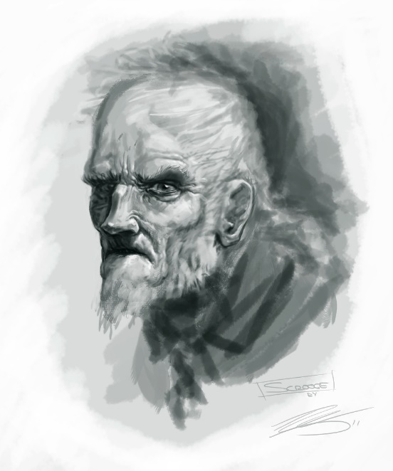
‘Shall we ask what Scrooge would actually be like if we were to follow him beyond the frame of the story? Unquestionably, he would relapse, when the merriment was over — if not while it was still going on — into moroseness, vindictiveness, suspicion. He would, that is to say, reveal himself as the victim of a manic-depressive cycle, and a very uncomfortable person.’
- Edmund Wilson (The Two Scrooges)

TASK: What do you think literary critic, Edmund Wilson, is saying here? What does he believe would really happen to Scrooge beyond the end of ‘A Christmas Carol’ and why? What exactly about Scrooge’s transformation do you think Wilson is criticising?

ACTIVITY FOUR: Charles Dickens
Read the information and complete the tasks

Dickens and Poverty
Dickens experienced prison and poverty in his own childhood. In 1824, London, John Dickens was locked in Marshalsea debtor’s prison for failing to pay his debts. His son, Charles, aged 11, was sent away to a blacking factory, covering and labelling pots of shoe polish in appalling conditions as well as loneliness and despair. He lived separated from his family, as his younger sister and mother were put in prison with his father. Later, he wrote in a letter with horror: ‘No words can describe the secret agony of my soul as I sank into this companionship…. The sense I had of being utterly neglected and hopeless, fired with grief and humiliation, my lonely vulnerability, my hungry misery, and the knowledge they had willingly put me in this situation. I could not bear to think of myself beyond reach of any honourable success.’ After three years he was returned to school, but the experience was never forgotten. Dickens lived just nine doors down from the workhouse until 1831, when he was 19 years old.
TASK ONE: SUMMARISE IT | TASK TWO: TRANSFORM IT
Summarise the information in fifty words or fewer. | Transform the information into TWO images. Label your images with quotations.
TASK THREE: CONSIDER IT
How do you think Dickens’ experiences as a child impacted his life as an adult? Answer in full sentences.

What did Dickens think of the law – and the poor – in England?
When Dickens wrote in 1830s London, English law was based on the idea of justice and a fair trial. However, Dickens found the law did not always practice what it preached. His father had been imprisoned in a debtor’s jail and Dickens separated from his family and sent to work in miserable conditions and lonely isolation when he was 11. Injustice, more often, was what Dickens experienced from the law for those in poverty.

Dickens became a lifelong supporter of the poor. For example, in January 1837, a trial was held at London Marylebone workhouse, and Dickens was on the jury. The case was a servant girl accused of killing her newborn baby, with the threat of the death penalty if she was found guilty. Eliza Burgess, weak, ill and frightened, was herself an orphan. Her story was that her baby appeared to be dead, so she hid it under the dresser but confessed to her employer. The jury was ready to find her guilty. That night, Dickens could not sleep: the dead baby, the thought of the terrified, unhappy, ignorant young woman in poverty and in prison. Dickens resolved to take on those who were ready to find her guilty. He argued so firmly and forcefully that he won the argument. The verdict was returned: not guilty. He then went out of his way to help victims of the law, even though he was under huge pressure himself to write and earn a living, to avoid debt and the debtor’s prison.

How did Dickens’ sister‐in law Mary die aged 17 in 1837?
Dickens’ beloved sister‐in‐law, Mary Hogarth, lived with the writer and his wife. Aged just seventeen, she became very ill with fever. Without warning, she died suddenly from it. Her death was a shock and Dickens carried the memory of Mary with him for the rest of his life. Dickens has his characters suffer from illness, but in his books, he can ensure they survive. Mary’s death never allowed Dickens to forget how fragile life is.

TASK ONE: SUMMARISE IT | TASK TWO: TRANSFORM IT
Summarise the information in fifty words or fewer. | Transform the information into TWO images. Label your images with quotations.

How and why did Dickens write his books?
Dickens’ books were originally published in monthly parts, and Dickens created each episode just in time to be published, so he could not go back and change anything, but had to plot it all out in his mind. He wrote professionally and raised himself and his family out of poverty through the popularity of his writing. Dickens wrote his books to challenge injustice and expose the impact of poverty in 19th century London.

ACTIVITY FIVE: Summarise your learning
Without looking at the information, see if you can summarise what you have learned about Charles Dickens in a mind map.
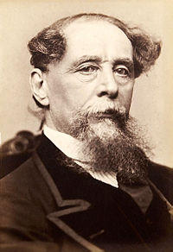

ACTIVITY SIX: Tier 2 Vocabulary Check
Revise the key vocabulary by completing the tasks.
destitute (adjective) extremely poor and lacking the means to provide for oneself.

TASK ONE: READ IT | TASK TWO: TRANSFORM IT
Read about the etymology of ‘destitute’. | Transform the adjective ‘destitute’ into an image to help you remember it.
Late 14c., "abandoned, forsaken," from Latin destitutus "abandoned," past participle of destituere "forsake," from de- "away" + statuere "put, place,"
Originally literal; sense of "lacking resources, impoverished" is 1530s.

TASK THREE: DEBATE IT
‘The issue of destitution in society will never be solved’. To what extent do you agree?
TASK FOUR: USE IT | TASK FIVE: LINK IT
Can you use the following words in a sentence?  destitute, destitution | Make a list of quotations from ‘A Christmas Carol’ that link to the adjective ‘destitute’.
1.

2.

ACTIVITY SEVEN: Thomas Malthus and Malthusian Controversy
Read the information and complete the tasks.
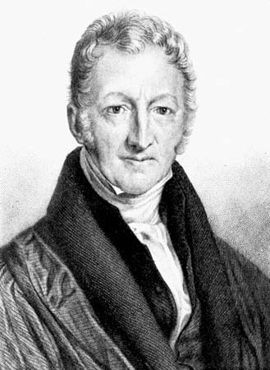
In his book An Essay on the Principle of Population, The Reverend Thomas Robert Malthus (13 February 1766 – 23 December 1834) observed that an increase in a nation's food production improved the well-being of the nation’s people, but the improvement was temporary because it led to population growth, which in turn restored the original per capita production level.
In other words, when mankind is doing well and producing lots of food and goods it does not use them to improve their own quality of life. Instead, they use that abundance of goods to have more children and increase the population. This meant there was no longer an abundance, but there was often a shortage instead.
In the past, populations grew until the lower classes suffered hardship and want. At this point, they became vulnerable to famine and disease – and often died.
Malthus thought we would never have a truly perfect (or utopian) society, because every time we came close to providing a great standard of life for everyone, the population grew and the process had to start again.
This idea became known as the Malthusian controversy and it was influential across economic, political, social and scientific thought. For our purposes, it’s important to see the big influence it had on Charles Dickens.
TASK ONE: SUMMARISE IT | TASK TWO: TRANSFORM IT
Summarise Thomas Malthus’ argument into fifty words or fewer. | Transform Thomas Malthus’ argument into two pictures. Label your images with quotations.
TASK THREE: Explain how you think Thomas Malthus and Malthusian controversy links to the ideas expressed in ‘A Christmas Carol’. Who, would you say, is the voice of Malthus in the novel? Discuss in full sentences.
TASK FOUR: How does the cartoon below illustrate Malthus’ ideas about population?
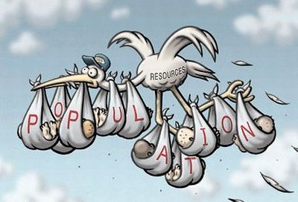

ACTIVITY EIGHT: ‘The Uncommercial Traveller’ by Charles Dickens
Complete the tasks below.
TASK ONE: Note down what you think of when you hear the word ‘workhouse’. These notes may take whatever form you like.
TASK TWO: Read Dickens’ description of a workhouse from his collection of semi-autobiographical essays called ‘The Uncommercial Traveller’.
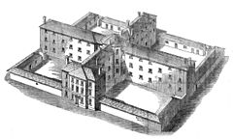
This was the only preparation for our entering ‘the Foul wards’. They were in an old building squeezed away in a corner of a paved yard, detached from the more modern and spacious main body of the workhouse. They were in a building most monstrously behind the time and only accessible by steep and narrow staircases, infamously ill-adapted for the passage up-stairs of the sick or down-stairs of the dead.
In these miserable rooms, here on bedsteads, there on the floor, were women in every stage of distress and disease. One figure a little coiled up and turned away, as though it had turned its back on this world for ever; the uninterested face at once lead-coloured and yellow, looking passively upward from the pillow; the haggard mouth a little dropped, the hand outside the coverlet, so dull and indifferent, so light, and yet so heavy; these were on every pallet; but when I stopped beside a bed, and said ever so slight a word to the figure lying there, the ghost of the old character came into the face, and made the Foul ward as various as the fair world. No one appeared to care to live, but no one complained; all who could speak, said that as much was done for them as could be done there, that the attendance was kind and patient, that their suffering was very heavy, but they had nothing to ask for. The wretched rooms were as clean and sweet as it is possible for such rooms to be; they would become a pest-house in a single week, if they were ill-kept.
Now, I reasoned with myself, as I made my journey home again, concerning those Foul wards. They ought not to exist; no person of common decency and humanity can see them and doubt it. But what is this Union to do? The necessary alteration would cost several thousands of pounds; it has already to support three workhouses; its inhabitants work hard for their bare lives.

How does Charles Dickens use language to present the conditions of the workhouse and its inhabitants?

You could include the writer’s choice of:
- words and phrases
- language features and techniques
- sentence forms

ACTIVITY NINE: Tier 2 Vocabulary Check
Revise the key vocabulary by completing the tasks.
parsimonious (adjective) unwilling to spend money or use resources.

TASK ONE: READ IT | TASK TWO: TRANSFORM IT
Read about the etymology of ‘parsimonious’. | Transform the adjective ‘parsimonious’ into an image to help you remember it.
1590s, from Latin parsimonia "frugality, thrift"

Not originally with the suggestion of stinginess.

TASK THREE: DEBATE IT
‘Are the advantages and disadvantages of being parsimonious equal?’
TASK FOUR: USE IT | TASK FIVE: LINK IT
Can you use the following words in a sentence?  Parsimonious, parsimoniously, parsimoniousness | Make a list of quotations from ‘A Christmas Carol’ that link to the adjective ‘parsimonious’.
1.

2.

3.

ACTIVITY TEN: Stave One quotations
Revise the key quotations in Stave One by completing the activities.
TASK ONE: Analyse the following quotations by answering the questions.
What language device has been used by Dickens here?
Why compare Scrooge to an oyster? What similarities do they share?

‘solitary as an oyster’

What is Dickens’ authorial intent? Why make Scrooge such a miserly character?
What are the connotations of the adjective ‘solitary’? Explore multiple interpretations.

What word types are these? What impression do they give you of the weather?
What is the significance of the personification of ‘biting’?

‘cold, bleak, biting weather’

What is Dickens’ authorial intent? Why make the weather so horrendous at the beginning? How does this set the tone for what is to come?
How is this an example of pathetic fallacy?

Explain how this quotations presents Fred as the antithesis of Scrooge.
What are the connotations of ‘glow’? How can this be seen in a positive sense?

‘He was all in a glow; his face was ruddy and handsome; his eyes sparkled.’

What is Dickens’ authorial intent? Why is it necessary for Fred to enter into the story when he does?
What impression does the verb ‘sparkled’ give us of Fred’s outlook on life?

What does the verb ‘forged’ imply?
What is the significance of Marley’s chain?

‘”I wear the chain I forged in life.”’

Marley’s appearance is that of the typical Victorian prisoner here. Why does Dickens give him this appearance?
How/why does Marley’s appearance plunge fear into Scrooge?

What is the significance of the adjective ‘incessant’?
What role does memory play at this point in the novel?

‘”No rest, no peace. Incessant torture of remorse.’”

What is Dickens’ authorial intent? Why present readers with the idea that ‘remorse’ can ‘torture’ them?
What are the connotations of ‘torture’?

What is the significance of this quotation? What is Marley saying?
What are the connotations of ‘business’?

‘”Mankind was my business.”’

Why say ‘WAS my business’? Why past tense?
Why does Dickens include this line?

ACTIVITY ELEVEN: Tier 2 Vocabulary Check
Revise the key vocabulary by completing the tasks.
implore (verb) beg someone earnestly or desperately to do something

TASK ONE: READ IT | TASK TWO: TRANSFORM IT
Read about the etymology of ‘implore’. | Transform the verb ‘implore’ into an image to help you remember it.
c. 1500, from Middle French implorer and directly from Latin implorare "call on for help, beseech, beg earnestly," with a literal sense probably of "plead tearfully, invoke with weeping," from assimilated form of in- "on, upon" + plorare "to weep, cry out"

TASK THREE: DEBATE IT
Is the act of imploring a sign of defeat?
TASK FOUR: USE IT | TASK FIVE: LINK IT
Can you use the following words in a sentence?  implore, imploring, imploringly | Make a list of quotations from ‘A Christmas Carol’ that link to the verb ‘implore’.
1.

2.

3.

ACTIVITY TWELVE: Scrooge’s conversion
Read the information from ‘Scrooge’s Conversion’ by Don R. Cox of the University of Missouri and complete the tasks.
TASK ONE: Read the following information.
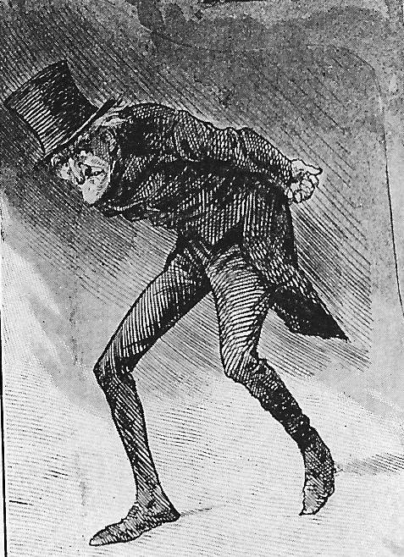
Dickens, whose works eternally celebrate Christmas, was not much of a Christian, strangely enough, and his theology is always a little fuzzy at best. If we look at ‘A Christmas Carol’ closely, for example, we see a story with a rather secular twist. When Scrooge makes his promise to ‘honour Christmas in my heart, and try to keep it all the year,’ we do not necessarily feel that he has become infused with a religious spirit and henceforth is constantly going to honour a holy day. The spirit that has seized his heart is not an angelic one but one that more probably resembles the Ghost of Christmas Present, a jolly bacchanalian ghost surrounded by ‘turkeys, geese, game, poultry, brawn, great joints of meat, sucking-pigs, long wreaths of sausages, mince-pies, plum-puddings, barrels of oysters, red-hot chestnuts, cherry-cheeked apples, juicy oranges, luscious pears, immense twelfth-cakes, and seething bowls of punch, that made the chamber dim with their delicious steam.’ It is not a series of holy spirits that converts Scrooge, but a series of spirits that shows him a materialistic world.
And why should Scrooge be converted by holy spirits anyway? Why should he experience a religious awakening? His ‘sin’ or ‘wickedness’ has not necessarily been a denial of religion. Even his name as it has passed into the language connotes Scrooge’s ‘sin’. He is a miser; he is tight with his money and will not give to the poor. He refuses the luxuries of life, keeps his rooms poorly heated, wrings his money’s worth out of Bob Cratchit, and will not participate in the festival of humanity that surrounds him. He is a kind of a grump perhaps, but he is not necessarily a wicked man. The ‘conversion’ that Scrooge experiences is not a holy revelation but an economic revelation. Scrooge saves his soul in the same way that Pickwick so often finds atonement – he spends money.

TASK TWO: Answer the following questions in full sentences.
- If something is ‘secular’ it means it is not connected with religious or spiritual matters. Do you agree with Don. R. Cox that Charles Dickens’ ‘A Christmas Carol’ is secular? If so, why do you think it is? Why has Dickens made the conscious decision to avoid discussing the links between Christmas and Christianity? Is there any evidence in the novel to suggest Cox’s argument is incorrect?

- ‘It is not a series of holy spirits that converts Scrooge, but a series of spirits that shows him a materialistic world’ – Do you think materialism is really the reason Scrooge changes?

- In your opinion, do you think Scrooge has denied religion in his life? What can you infer from the information we are given about him in the text?

ACTIVITY THIRTEEN: Tier 2 Vocabulary Check
Revise the key vocabulary by completing the tasks.
cordial (adjective) warm and friendly

TASK ONE: READ IT | TASK TWO: TRANSFORM IT
Read about the etymology of ‘cordial’. | Transform the adjective ‘cordial’ into an image to help you remember it.
c. 1400, "of or pertaining to the heart" (a sense now obsolete or rare, replaced by cardiac), from Medieval Latin cordialis "of or for the heart," from Latin cor "heart"

TASK THREE: DEBATE IT
Can being cordial ever have negative consequences?
TASK FOUR: USE IT | TASK FIVE: LINK IT
Can you use the following words in a sentence?  cordial, cordially, cordiality | Make a list of quotations from ‘A Christmas Carol’ that link to the adjective ‘cordial’.
1.

2.

3.

ACTIVITY FOURTEEN: Stave Two quotations
Revise the key quotations in Stave Two by completing the activities.
TASK ONE: Analyse the following quotations by answering the questions.
What are the connotations of the adjective ‘strange’?
Why is the language here full of contradiction and antithesis?

‘It was a strange figure – like a child: yet not so like a child as like an old man.’

What is Dickens’ authorial intent? Why make this spirit such an odd character?
What are the connotations of the noun ‘child’?

How does this quotation link to themes of light and dark?
Why does the spirit describe Scrooge’s hands as ‘worldly’?

‘”Would you so soon put out, with worldly hands, the light I give?”’

How does the light Scrooge is surrounded by contrast with the events of Stave One?
What is Dickens’ authorial intent with this question?

The adjective ‘feeble’ implies Scrooge is not surrounded by much warmth or light. What could this symbolise?
What are the connotations of the adjective ‘lonely’?

‘A lonely boy was reading near a feeble fire.’

Why is it important that Scrooge sees this image?
What is Dickens’ authorial intent here?

What are the connotations of each of the adjectives?
Why does the spirit take Scrooge to see Fezziwig?

‘He called out in a comfortable, oily, rich, fat, jovial voice.’
How do these adjectives contrast to the way Scrooge’s voice was described in Stave One?
What is Dickens’ authorial intent here?

What are the connotations of the noun ‘idol’?
What is Dickens’ authorial intent here?

‘”Another idol has displaced me.”’

What does the word ‘another’ suggest about the relationship between Belle and Scrooge?
Why is it important that Scrooge sees this image?

What are the connotations of the verb ‘streamed’?
The fact that he cannot hide the light anymore suggests what about Scrooge?

‘He could not hide the light: which streamed from under it, in an unbroken flood upon the ground.’

How does this quotation link to the themes of light and dark?
What does the ‘unbroken flood’ imply about the light?

ACTIVITY FIFTEEN: Low Stakes Quiz
Answer the multiple choice questions.
A Reminder of Stave One! | A Reminder of Stave Two!
Who is Jacob Marley?  - Scrooge’s office clerk  - Scrooge’s current business partner  - Scrooge’s former business partner  - Scrooge’s nephew  Who is Bob Cratchit?  - Scrooge’s office clerk  - Scrooge’s current business partner  - Scrooge’s former business partner  - Scrooge’s nephew  Scrooge is a solitary as an…  - A shrew  - An oyster  - A crab  - A hermit  Who are the charitable gentlemen collecting for?  - Ignorance and Want  - Orphans and Children  - Poor and Destitute  - Workhouses and Prisons  What does Scrooge want to decrease?  - The surplus population  - Joy in Christmas  - The amount given to charity  - Bob Cratchit’s wages  What is Marley weighed down by?  - Heavy sandbags  - Chains made of padlocks and cashboxes  - His guilty conscience  - Iron weights  What does Marley say was his ‘business’?  - Making profit  - Charitable acts  - Mankind  - Helping Scrooge | Who or what is Fezziwig?  - The local wig shop  - The name of Scrooge’s favourite drink  - Scrooge’s crazy uncle  - Scrooge’s boss when he was younger  What bad news does Belle give Scrooge?  - His mother has died  - She is calling off their engagement  - She is moving away  - He has lost his job  What does Scrooge come to understand after viewing the Fezziwig scene?  - How lonely he was as a young man  - That everyone knew how to have fun except him  - The benefits of kindness  - The time it takes to develop strong relationships  What is the first place the ghost takes Scrooge to visit?  - His grandmother’s kitchen  - His first office  - His boyhood schoolhouse  - His college dorm room  - His first pace of work  How is Scrooge able to fly out the window with the ghost?  - By holding his ankle  - By climbing on his back  - By grasping his robe  - By touching his hand  How does Belle seem to Scrooge when the ghost takes him to observe her several years later?  - Poor  - Angry  - Happy  - Sad
ACTIVITY SIXTEEN: Tier 2 Vocabulary Check
Revise the key vocabulary by completing the tasks.
jocund (adjective) cheerful and light-hearted

TASK ONE: READ IT | TASK TWO: TRANSFORM IT
Read about the etymology of ‘jocund’. | Transform the adjective ‘jocund’ into an image to help you remember it.
Late 14c., "pleasing, gracious; joyful," from Old French jocond or directly from Late Latin iocundus (source of Spanish jocunde, Italian giocondo), variant (influenced by iocus "joke") of Latin iucundus "pleasant, agreeable."
TASK THREE: DEBATE IT
Can people be too jocund? Is this a bad thing?
TASK FOUR: USE IT | TASK FIVE: LINK IT
Can you use the following words in a sentence?  jocund | Make a list of quotations from ‘A Christmas Carol’ that link to the adjective ‘jocund’.
1.

2.

3.

ACTIVITY SEVENTEEN: Stave Three quotations
Revise the key quotations in Stave Three by completing the activities.
TASK ONE: Analyse the following quotations by answering the questions.
What are the connotations of the adjective ‘jolly’?
How does the torch link to the theme of light?

‘There sat a jolly Giant, glorious to see; who bore a glowing torch… and held it up, high up, to shed its light on Scrooge.’
Why a ‘giant’? What is the significance of this?
Why does Dickens emphasise how high the torch is held?

What does the adjective ‘sufficient’ tell you about the Cratchits?
Discuss the theme of family. Why does Dickens include it?

‘It was a sufficient dinner for the whole family.’

What is the purpose of the Cratchits? Why are they there?
Why does Scrooge need to see this?

How are the Cratchits the antithesis of Scrooge?
How does Dickens use the Cratchits to emphasise the importance of Christmas?

‘There was nothing of high mark in this. They were not a handsome family; they were not well dressed; their shoes were far from being water-proof; their clothes were scanty.’
Why is it important for Scrooge to see this?
Why does Dickens go to such great lengths to emphasise the poverty the Cratchits live in?

Why does Dickens make the Ignorance and Want children?
What is the effect of these adjectives?

‘They were a boy and girl. Yellow, meagre, ragged, scowling, wolfish: but prostrate, too, in their humility.’

Why is the significance of the fact they are ‘prostrate in their humility’?
What is Dickens’ authorial intent here?

ACTIVITY EIGHTEEN: Tier 2 Vocabulary Check
Revise the key vocabulary by completing the tasks.
malevolent (adjective) having or showing a wish to do evil to others

TASK ONE: READ IT | TASK TWO: TRANSFORM IT
Read about the etymology of ‘malevolent’. | Transform the adjective ‘malevolent’ into an image to help you remember it.
c. 1500, from Middle French malivolent and directly from Latin malevolentem
"ill-disposed, spiteful, envious," from male "badly" + volentem, present participle of velle "to wish"

TASK THREE: DEBATE IT
Does being malevolent have its advantages?
TASK FOUR: USE IT | TASK FIVE: LINK IT
Can you use the following words in a sentence?  malevolent, malevolence, malevolently | Make a list of quotations from ‘A Christmas Carol’ that link to the adjective ‘malevolent’.
1.

2.

3.
ACTIVITY NINETEEN: Stave Four quotations
Revise the key quotations in Stave Four by completing the activities.
TASK ONE: Analyse the following quotations by answering the questions.
Why is this ghost silent? Why, unlike the others, does the ghost not tell Scrooge what he has done wrong?
What are the connotations of these adverbs?

‘The Phantom slowly, gravely, silently, approached.’
Why is this ghost referred to as a ‘phantom’ and not a ‘spirit’?
How does this description instil a sense of fear in Scrooge and the reader?

How does this ghost differ from the others? Why does this ghost have to create a sense of fear?
What is Dickens saying about the ghost? Why is it ‘immovable’?

‘The Spirit was immovable as ever.’

What is Dickens’ authorial intent here?
Why add ‘as ever’ on the end? What is the significance of this?

Scrooge says he will ‘try’ to keep it all the year. Why ‘try’? Why not ‘will’?
‘I will live in the Past, Present and Future’. What does this mean?

“’I will honour Christmas in my heart, and try to keep it all the year. I will live in the Past, Present, and the Future. The Spirits of all Three shall strive within me. I will not shut out the lessons that they teach. Oh, tell me I may sponge away the writing on this stone.”’
What is Dickens’ authorial intent here?
What is the significance of the word ‘strive?

TASK TWO: ‘Scrooge does not change because he has truly seen the errors of his ways. He changes because he is still selfish and scared of what will happen if he does not.’ To what extent do you agree?

ACTIVITY TWENTY: Low Stakes Quiz
Answer the multiple choice questions.
Stave One  Scrooge is a solitary as an…  - A shrew  - An oyster  - A crab  - A hermit  What does Scrooge want to decrease?  - The surplus population  - Joy in Christmas  - The amount given to charity  - Bob Cratchit’s wages  What does Marley say was his ‘business’?  - Making profit  - Charitable acts  - Mankind  Helping Scrooge  Stave Two  How does the Ghost of Christmas Past describe the young Scrooge?  - A solitary child, neglected by his friends  - An evil child, neglected by his friends  - A solitary child with no friends  - A popular child with lots of friends  What bad news does Belle give Scrooge?  - His mother has died  - She is calling off their engagement  - She is moving away  - He has lost his job  What is the first place the ghost takes Scrooge to visit?  - His grandmother’s kitchen  - His first office  - His boyhood schoolhouse  - His college dorm room  - His first pace of work | Stave Three  How is the Ghost of Christmas Present represented?  - A jolly giant  - A silent phantom  - A small glowing man  - An invisible spirit  Who are the children under the Ghost of Christmas Present’s coat?  - Poor and Destitute  - Hope and Charity  - Ignorance and Want  - Goodness and Light  Which line does the Ghost of Christmas Present repeat to Scrooge?  - “Are there no prisons? Are there no workhouses?”  - “Christmas? Bah humbug!”  - “Decrease the surplus population.”  - “You may be a bit of undigested beef.”  Context  Who might the Ghost of Christmas Present represent?  - Father Christmas  - Scrooge’s father  - God  - Jacob Marley  Which words best describe 19th century Victorian London?  - Happy, wealthy and wise  - Dangerous, crowded, filthy  - Violent, murderous, insane  - Clean, healthy and safe  Malthus believed…  - We can’t improve our lives if the population increases  - We can’t improve our lives until the population increases  - We can’t improve our lives unless we earn more money  - We can’t improve our lives unless we do more for charity

ACTIVITY TWENTY ONE: Stave Five quotations
Revise the key quotations in Stave Five by completing the activities.
TASK ONE: Analyse the following quotations by answering the questions.
What is Dickens’ authorial intent? Why does he show us this?
How do these similes contrast the similes used in Stave One?

‘”I am as light as a feather, I am as happy as an angel, I am as merry as a school-boy.”’
What are the connotations of an ‘angel’?
Why is it significant that Scrooge mentions a ‘merry school-boy’?

Now there is no fog unlike the descriptions in Stave One. What do you think the fog and mist could have symbolised?
Why do you think Dickens has given the novella a cyclical structure?

‘No fog, not mist; clear, bright, jovial, stirring, cold.’

Why does Dickens list the qualities of the cold?

What are the connotations of these adjectives?

What is Dickens’ authorial intent here?
What are the connotations of ‘heart’?

‘His own heart laughed: and that was quite enough for him.’
What is the significance of ‘that was quite enough for him’?

Why do you think Tiny Tim is the one to say this?
Why make this the last line of the novella?

‘And so, as Tiny Tim observed, God bless Us, Every One!’

Why is the significance of ‘every one’?
What is Dickens’ authorial intent here?

ACTIVITY TWENTY TWO: Tier 2 Vocabulary Check
Revise the key vocabulary by completing the tasks.
beneficent (adjective) generous, selfless

TASK ONE: READ IT | TASK TWO: TRANSFORM IT
Read about the etymology of ‘beneficent’. | Transform the adjective ‘beneficent’ into an image to help you remember it.
1610s, "doing good, charitable through good will," probably from beneficence on model of magnificent, etc. The Latin adjective is beneficus.

TASK THREE: DEBATE IT
Does beneficence exist in modern society?
TASK FOUR: USE IT | TASK FIVE: LINK IT
Can you use the following words in a sentence?  beneficent, beneficence | Make a list of quotations from ‘A Christmas Carol’ that link to the adjective ‘beneficent’.
1.

2.

3.

ACTIVITY TWENTY THREE: ‘A Christmas Carol’ is a defence of charity – and capitalism
Read the information by Brandon Ambrosino and complete the activities.
TASK ONE: Read the following information.
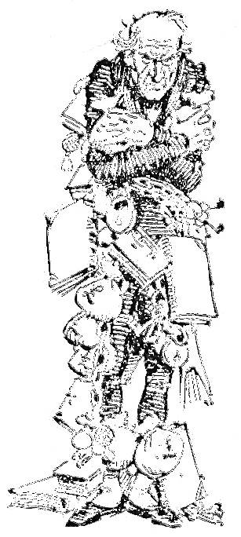
Introduction: Marley was dead: to begin with.
That's one of the most famous opening lines of any work of English literature. It is, of course, the beginning of Charles Dickens's A Christmas Carol, his 19th-century tale about the miserly Scrooge, who, after a visit from three holiday sprites, discovers the joy of the holidays.
Dickens published the novella in December 1843, and it was an instant hit, first in his home country and then across the pond in America. In fact, since it was published some 170 years ago, it hasn't ever been out of print. But in spite of the popularity of the work, Dickens was disappointed by his earnings from the book.
As Jon Michael Varese notes in the Guardian, the book sold its first printing of 6,000 copies by Christmas Eve 1843. By the close of the following year, the book had sold more than 15,000 copies. Dickens made £726, a sum of money that he found disappointing.
In a letter to John Forster, his literary advisor, Dickens wrote that he'd hoped to bring in at least £1,000. "What a wonderful thing it is," he wrote, "that such a great success should occasion me such intolerable anxiety and disappointment!" Varese, too, thinks the publication wasn't a financial success.
Still, it's worth noting that £726 was a lot of money in 1843. Correcting for inflation over 170 years isn't an exact science, but the Bank of England says £726 in 1843 is around £80,000 ($125,000) in today's money. For comparison, the protagonist of A Christmas Carol, Bob Cratchit, made 15 shillings, or £0.75, per week. So Dickens made almost as much from two years of Christmas Carol sales as Cratchit would have made in 20 years of working for Mr. Scrooge.
Forster believed they could have made even more from the book if they'd charged more for it. The book sold for 5 shillings (£0.25), which was, in fact, high for that time period. But considering Dickens's lavish requirements for his publisher — gold lettering on the front and back, four full-page color etchings, gilded page edges, a bright red and green title page — 5 shillings was less than it could have sold for.
As Varese notes, Dickens set the price at an affordable rate so that it could be easily accessible to most people. And not just because he wanted to provide all of London with Christmas cheer, but because he wanted to give them a lesson in economics.

Why Dickens wrote A Christmas Carol
In the fall of 1843, Dickens visited Samuel Starey's Field Lane Ragged School, a school that "educated slum children," according to the New York Times. Dickens easily empathized with such children living in poverty, coming, as he did, from a poor childhood himself — a fact that set him apart from many other English authors, like Jane Austen and the Brontë sisters, who enjoyed the social and class privilege of their births. To this day, Dickens is remembered for his empathy with those living in poverty. As his tombstone reads, "He was a sympathiser with the poor, the suffering, and the oppressed..."
When his father was sent to debtors' prison, 12-year-old Dickens had to take a job at a blacking factory, where for up to 12 hours a day he pasted labels onto pots of boot polish. He was paid 5 or 6 shillings (£0.25 to £0.3) a week for his labor, and that price went directly to help his family make ends meet.
On October 5, Dickens was asked to deliver a lecture at the first annual meeting of the Manchester Athenaeum, an institution that provided education and recreation to the laboring classes. Dickens used the opportunity to speak against systemic poverty and injustice: "Thousands of immortal creatures are condemned ... to tread, not what our great poet [Shakespeare] calls the 'primrose path to the everlasting bonfire,' but over jagged flints and stones laid down by brutal ignorance."
After delivering the address, Dickens planned to write a pamphlet titled, "An Appeal to the People of England on Behalf of the Poor Man's Child," treating many of the themes he'd spoken about in Manchester. However, the pamphlet was never written, as the author chose instead to give his economic ideas flesh and blood — and, importantly, a wobbly leg — in the form of a story.

Scrooge, everyman
The word "Scrooge" has become synonymous with greed, the word we use for someone miserly, penny-pinching, and merciless. As Dickens writes of his main character, Scrooge was "a tight-fisted hand ... a squeezing, wrenching, grasping, scraping, clutching, covetous, old sinner."
But though he doesn't give away any of his money, and though he feels no sympathy for those less fortunate than he, Scrooge, as Dickens makes clear, is no criminal. He works hard for his money, day in and day out. And though he seems heartless, he's clearly not villainous, like Dickens's Sikes, the dog-beating criminal from Oliver Twist who ends up murdering his girlfriend.
He's also, as English professor Lee Erikson writes, quite similar to others of his day, who "feared not just the Spirit of Christmas Yet to Come but the financial future, which seemed likely in the deflationary moment of December 1843 to be very bleak." That is, Scrooge, like many other mid-19th-century businessmen, was concerned about the future of the economy, and was therefore "tight-fisted," in case things took a turn for the worse.
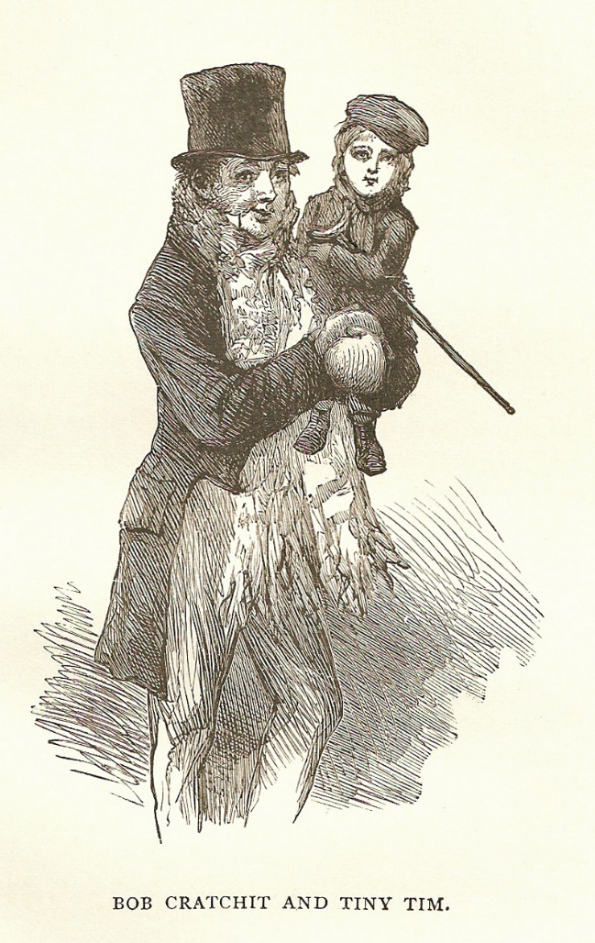
As Erickson notes, by the time Dickens published A Christmas Carol:
the prices of goods in England had been falling for the past four years and had fallen during that time a total of 22.72 percent. During this period, the rate of deflation had thus been 5.68 percent a year; and, in particular, retrospective price indexes show that prices had fallen and the purchasing power of a pound had risen by five-and-a-half percent from the end of 1842 to the end of 1843. As a consequence, those with income in excess of their needs were spending no more at present than they had to spend …
In the opening scene when we meet Scrooge, two men show up to his office to ask for charity. Scrooge, of course, offers no money, since, he argues, there are prisons and union workhouses, not to mention poverty laws, to provide for the lower classes. Scrooge didn't protest these government programs — he just thought they were sufficient for those in need.
But as Dickens powerfully argues, those programs are not sufficient. Charity is still necessary.

The economics of A Christmas Carol
Some have read A Christmas Carol as espousing socialism, but the book doesn't decry capitalism. To be sure, Dickens condemns greed, but that is just one negative effect of a free market, not its defining feature.
In Dickens, the remedy to greed is not socialism — it's charity.
After being convinced by three spirits to mend his ways, Scrooge does in fact improve himself, and becomes something of a philanthropist. He provides dinner for the Cratchits and medical care for Tiny Tim, none of which would have been possible for Scrooge if he hadn't been a successful, shrewd businessman. In other words, capitalism was the very condition that made Scrooge's philanthropy possible. Scrooge's wealth, Dickens argues, is actually a very good thing, when generously distributed.
And Dickens practiced what he preached. He earned a comfortable living as a writer, and he used his wealth and influence to help those less fortunate. One of Dickens's main projects was helping to establish Urania Cottage, a 19th-century safe house where women who led lives of crime and prostitution were given shelter, an education, and a chance to start over.
Though Dickens's classic story is set at Christmastime, the principles at its heart are meant to be read — and practiced! — year round. This is all the more apparent once you understand the author's noble reasons for publishing the work. It was Dickens's hope that all of his readers would come to the same conclusion as his repentant Scrooge:
"I will honour Christmas in my heart, and try to keep it all the year. I will live in the Past, the Present, and the Future. The Spirits of all Three shall strive within me. I will not shut out the lessons that they teach!"
TASK TWO: Summarise each section in fifty words or fewer.
Introduction | Why Dickens wrote ‘A Christmas Carol’
Scrooge, everyman | The economics of ‘A Christmas Carol’
NOTES
Make any additional notes here.

